**AI Assisted Coding**

**NAME:** K. Siri Chandana

**HTNO:**2403A51282

**BATCH:12**

**TASK1: Auto-Complete a Python Class for Bank Account**

**•**Write a class definition comment and start the constructor for a class called Bank Account with account_holder and balance attributes. Use GitHub Copilot to auto-complete the rest of the class, including methods to deposit, withdraw, and display balance.

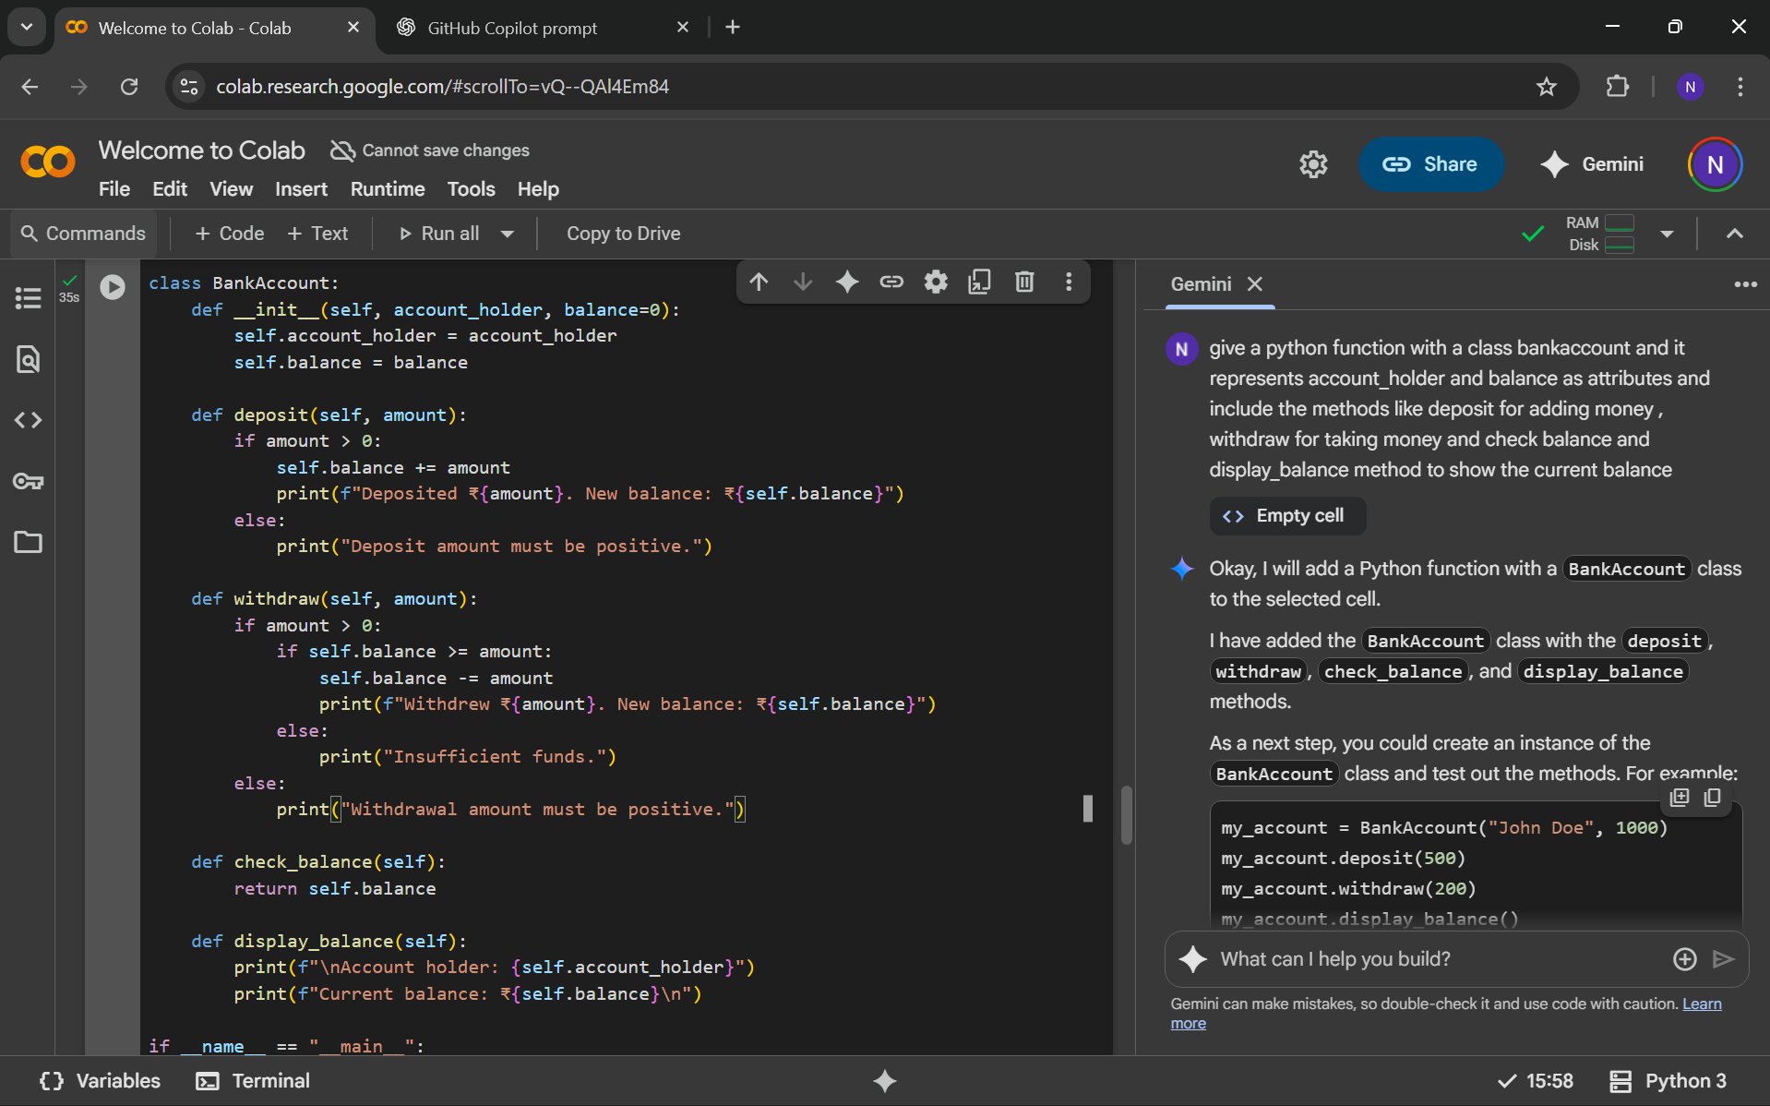

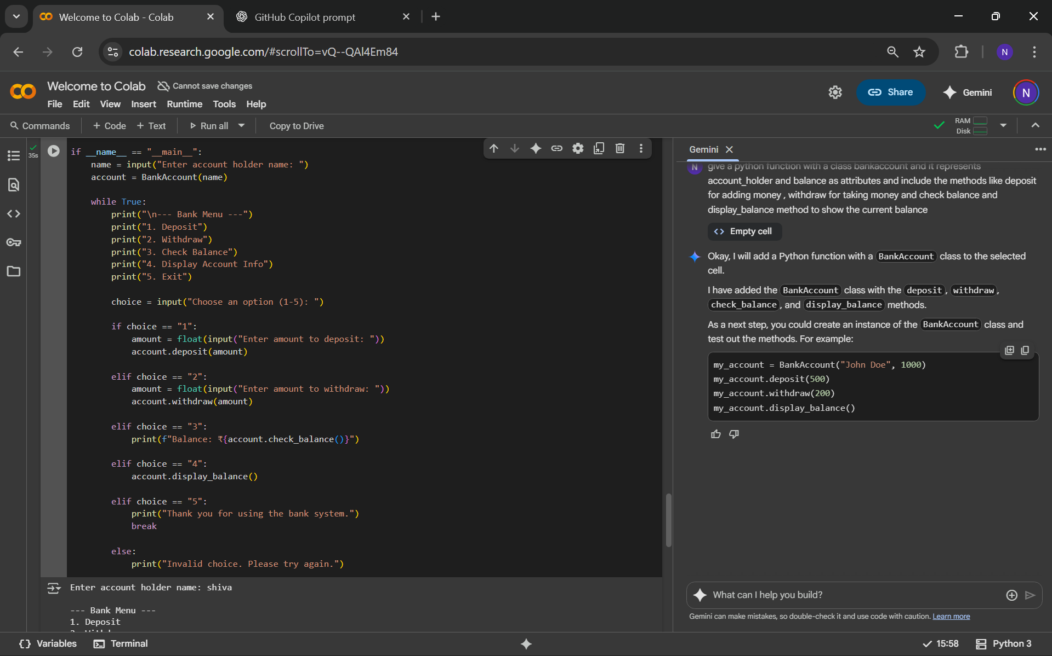

**Output:**

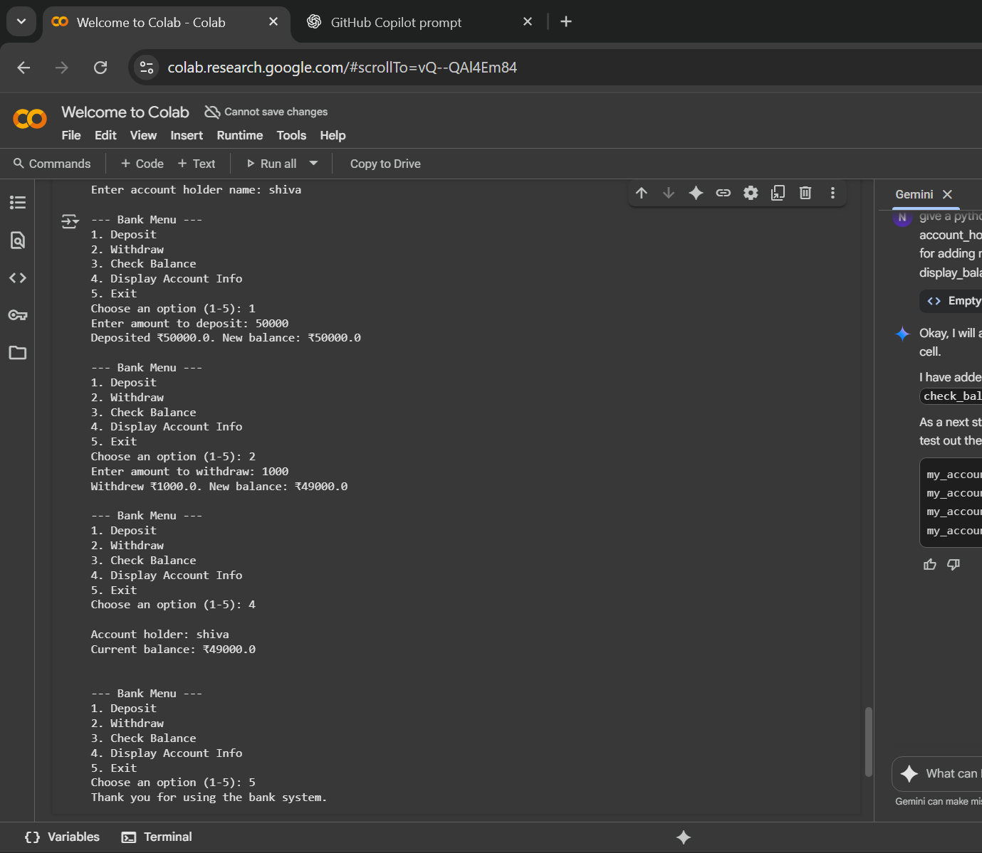

**Task 2: Auto-Complete a For Loop to Sum Even Numbers in a List**

* Write a comment and the initial line of a loop to iterate over a list. Allow GitHub Copilot to complete the logic to sum all even numbers in the list

**Expected Output #2**

• Code that:  
• Iterates over a list  
• Checks if the number is even using % 2 == 0  
• Accumulates the sum  
• Sample input/output:

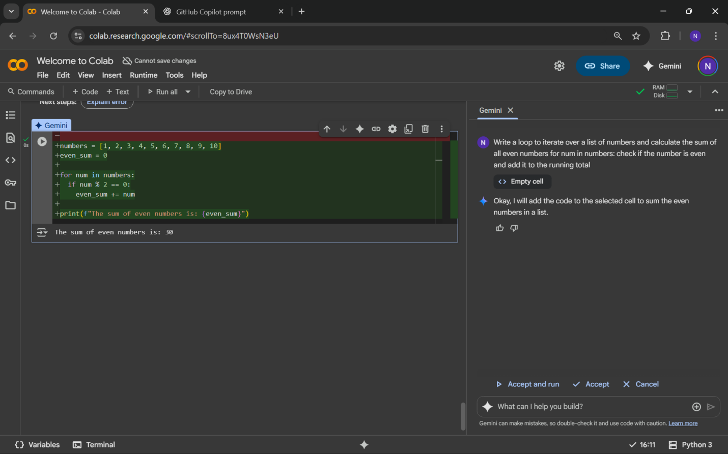

**Task 3: Auto-Complete Conditional Logic to Check Age Group**• Start a function that takes age as input and returns whether the person is a child, teenager, adult, or senior using if-elif-else. Use Copilot to complete the conditionals.

**Expected Output #3**  
• Function like: Output for age_group(45) ➝ "Adult”

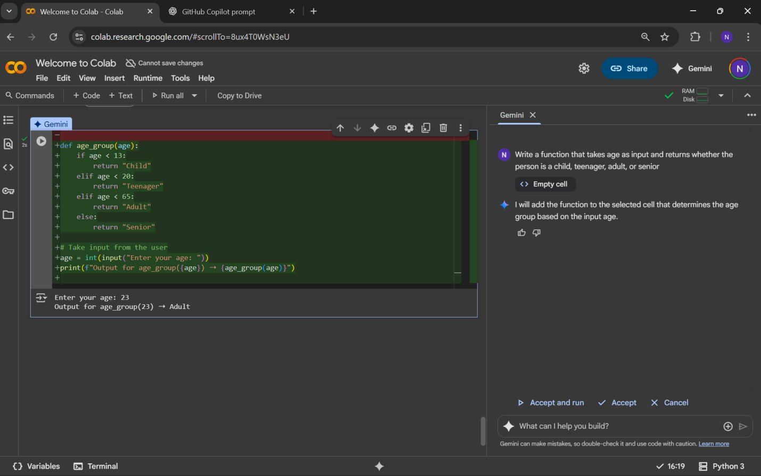

**Task 4: Auto-Complete a While Loop to Reverse Digits of a Number**

**• Write a comment and start a while loop to reverse the digits   
• Write a comment and start a while loop to reverse the digits of a number. Let Copilot complete the loop logic.**

**Expected Output #4**

**• Functional loop: Output: 4321**

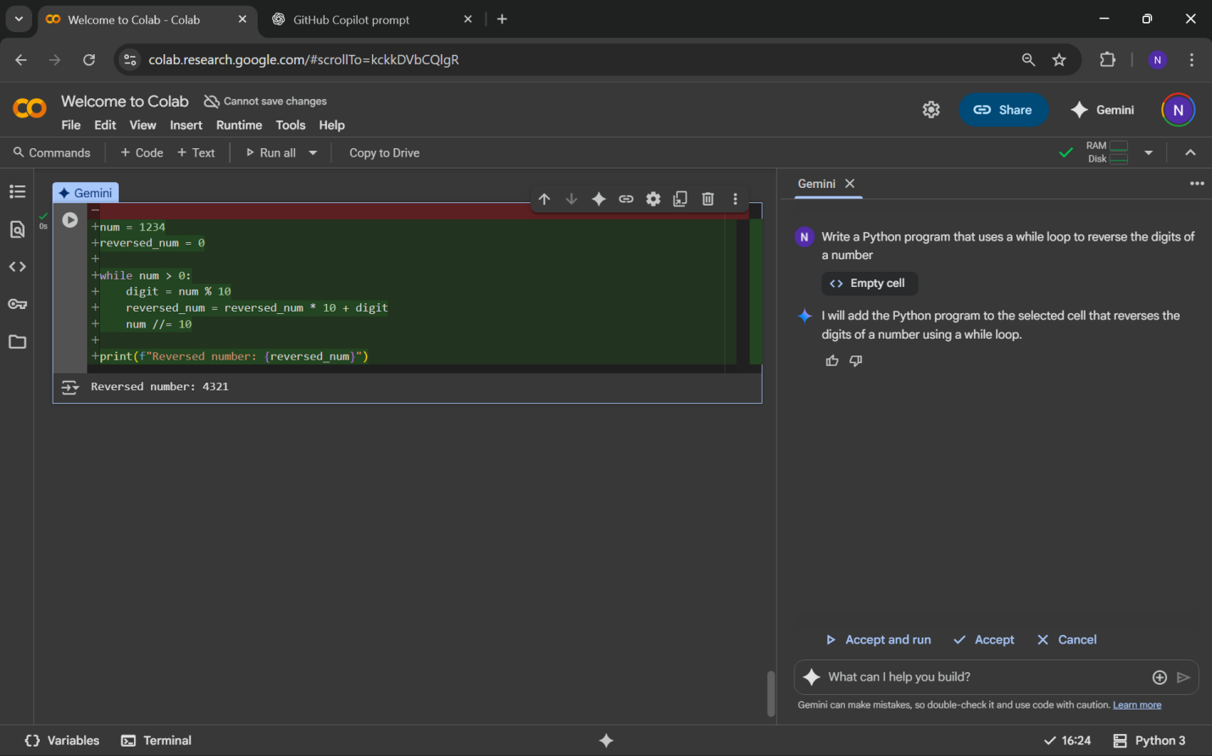

**Task 5: Auto-Complete Class with Inheritance (Employee → Manager)**

• Begin a class Employee with attributes name and salary. Then, start a derived class Manager that inherits from Employee and adds department. Let GitHub Copilot complete the methods and constructor chaining.

**Expected Output #5**

• Auto-generated code like:  
Name: John, Salary: 50000, Dept: IT

